Report on

**Electromagnetic Methods for the Determination of Early Stage Fatigue**

Methods

1. Magnetic Barkhausen Noise
2. Non-Linear Eddy Current

EPRI Task ID: 1-110095-01-04

Nondestructive Evaluation Lab of Michigan State University

**Introduction and Objective:**

Stainless steel shows excellent mechanical properties at elevated temperatures and is, therefore, used very widely in applications involving operation at high temperatures. Martensitic grade stainless steel is used, for example, to manufacture steam turbine blades in power plants. The failure of these turbine blades can result in equipment damage contributing to expensive plant failures and safety concerns. Plastic deformation is one of the primary factors leading to material degradation and the structural failure of key structural components. It is of vital importance to evaluate the level of plastic deformation prior to the initiation of macro defects in order to ensure the viability of these components. The detection of conditions that lead to the development of cracks can reduce overall operational and maintenance costs. Conventional Nondestructive Evaluation techniques such as Ultrasonic Testing (UT) and Eddy Current Testing (ECT) are good candidates for detecting macro defects (cracks, corrosion etc.), but not effective for the evaluation of the material degradation due to fatigue. Fatigue cracks that are too small to be detected in one inspection can potentially become large enough to cause failure before the next inspection cycle. Consequently, a nondestructive electromagnetic technique, which is sensitive to microstructure changes in the material, is needed to provide a means to detect early onset of fatigue.

The objective of this work is to study the feasibility of using t*wo* different electromagnetic *methods,* Magnetic Barkhausen Noise (MBN) and Non-Linear Eddy Current (NLE) for the detection of fatigue damage. The EPRI sample inventory will be used in this study to investigate the efficacy of features or metrics extracted from the proposed EM NDE data in detecting early fatigue damage in a test sample.

**Method 1: MBN**

**1.1 Experimental Setup**

Magnetic Burkhouse noise (MBN) is a promising nondestructive electromagnetic method for characterizing properties of the ferromagnetic materials according to its high sensitivity to microstructure change. Magnetic materials consist of magnetic domains with its individual magnetic moments. Without the applied magnetic field, magnetic domains are randomly oriented. In the presence of a changing magnetic field, the walls separating the domains move so that domains aligned close to the field direction grow at the expense of those that are less aligned. The movement occurs in a series of sudden jumps as the domain walls break away from pinning sites such as dislocations, precipitates and grain boundaries. This leads to corresponding sudden changes in the magnetization of the material and generate small pulses, which is referred to as the magnetic Barkhausen noise.

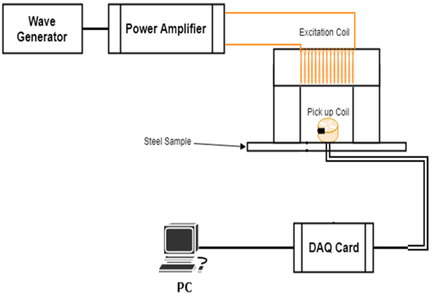

Figure 1.1: MBN Block Diagram

Figure 1.1 shows the block diagram of MBN set-up. The wave generator is used to generate a low frequency sinusoidal signal which is further amplified using a power amplifier and then given to the excitation coil. The pick-up coil shown in figure picks the MBN signature (voltage) generated by the steel sample under test and gives it to the NI DAQ card, which is further processed using LabView to generate the MBN data file. The obtained MBN datafile is processed in MATLAB to obtain features relating to the fatigue life of the steel sample. The excitation and pick-up coil are shown Figure 1.2.

Figure 1.2: Excitation & Pick-Up coil

The experimental parameters are set in the following way:

* Wave generator output: Sinusoidal signal of 4V (peak to peak) and frequency of 5 Hz
* Power amplifier gain: 10 V/V
* Pickup coil: 400 turns
* Excitation coil: 80 turns
* Sampling rate: 200,000 Sa/s

**1.2 Data Collection Process:**

Figure 1.3: scanning points

MBN data is collected at nineteen different points, with eighteen of them on the 3 X 6 grid representing the fatigued area and one in the un-fatigued part, i.e. the reference data (shown in Figure 1.3). The process is automated by using PYTHON code and a holder for mounting the MBN sensor assembly consisting of the core, pick up and excitation coil. The data is stored as a .txt file and then processed in MATLAB to obtain different features.

**1.3 Data Analysis & Proposed Features:**

The signal energy representing the intensity of the Barkhausen noise, is measured by the root-mean-square value which is correlated with the properties of metals. Acquired MBN signals are averaged over 5 cycles to eliminate random measurement noise and then processed in MATLAB program for subsequent feature extraction.

Various features were considered and evaluated in time domain which is based on signal’s profile (peak value, peak position, full width at half maximum, gaps between two gaussian fitting curves and variances among three gaussian fitting curves) and in frequency domain which is based on frequency spectrum (maximum frequency spectrum amplitude, frequency for maximum amplitude and energy). Finally, two parameters in time domain and three parameters in frequency domain were identified as potential features for detecting early fatigue damage. These features are illustrated below.

In time domain, the periodic MBN signal at each scan position of a sample is modeled by a mixture of 2 Gaussian distributions. In this project, the signal peak value and full width at half maximum (FWHM) are computed by the algorithm.

* Feature 1: MBN signal peak (time domain)

Peak of MBN signals represents movement of reverse domain walls from the grain boundaries. Figure 1.4 shows the envelope of one period Magnetic Barkhausen Noise’s and the peak value detected.

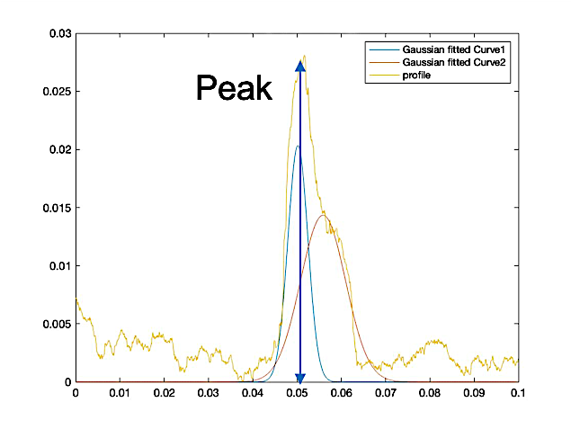

Figure 1.4: Envelope of Magnetic Barkhausen Noise signal with detected peak

* Feature 2: FWHM of MBN signal envelope (time domain)

Full width at half maximum is the distance between points on the curve at which the function reaches half its maximum value. FWHM of MBN signals denotes distribution of domain wall pinning strength of phase boundaries. The fitted MBN signal described by a gaussian pdf has following the definition of FWHM (eq.1.).

(1)

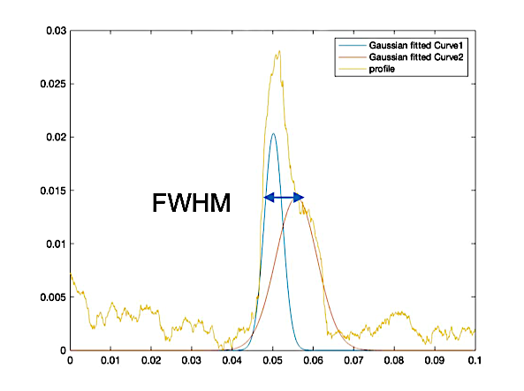

Figure 1.5: MBN signal envelope and FWHM

Figure 1.5 shows the one period Magnetic Barkhausen Noise’s proﬁle and the FWHM representation.

Fast Fourier Transformation (FFT) is applied to time domain MBN signals to obtain the frequency spectrum of the MBN signal. In frequency domain, maximum frequency spectrum amplitude, frequency of maximum amplitude and energy are chosen as features. A bandpass filter from 1.5kHz to 20kHz is applied to obtain the relevant frequency components.

* Feature 3: Maximum Spectrum Amplitude (Frequency domain)

The peak of frequency spectrum is detected by the MATLAB program and is shown in Figure 1.6.

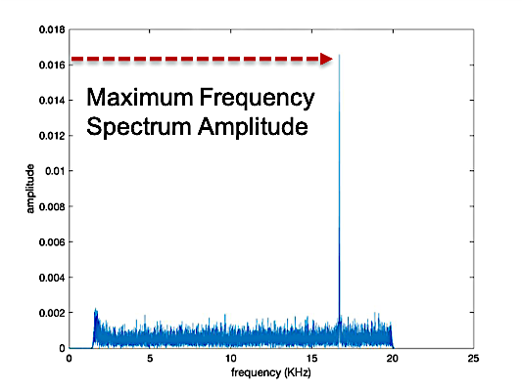

Figure 1.6: Frequency spectrum with noted maximum frequency spectrum amplitude

* Feature 4: Frequency of Maximum Spectrum Amplitude (Frequency Domain)

The position of the maximum frequency spectrum is detected by the MATLAB program and is shown in Figure 1.7.

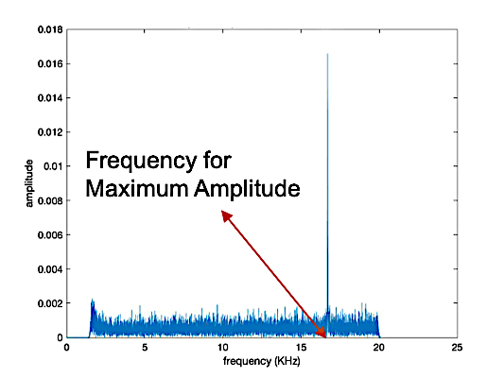

Figure 1.7: Frequency spectrum with noted position of maximum frequency spectrum amplitude

* Feature 5: MBN signal energy

The MBN energy is found to be related grain boundary misorientation angle, which influences the arrangement of magnetic domains along the boundary. According to the Parseval's theorem, a signal's energy in the time domain as well as in the frequency domain are always equal. Based on the definition, MBN signal’s energy is computed by the summation across all frequency components of the signal's spectral energy density.

**1.4 Results:**

|  |  |
| --- | --- |
| Sample Category | Loading Cycles |
| No-Fatigue | 0 |
| Mid-Fatigue | 150k – 750k |
| High-Fatigue | 900k – 200,000k |
| Cracked | - |

For every selected feature in each EPRI sample, values at 18 scanning points are averaged and then normalized with respect to the corresponding value at the reference point. The normalization process can be described in a way that:

denoted as each scanning point at fatigue area, is the sample number while is the corresponding feature. is considered as each sample point’s feature representation, and is the corresponding reference point’s feature. The normalized feature value for each sample are then plotted, which are shown in Figures 1.8 – 1.12.

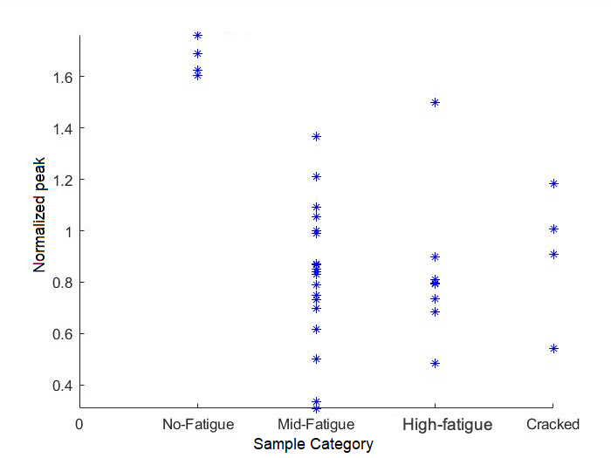

Figure 1.8: Feature 1 - MBN signal peak

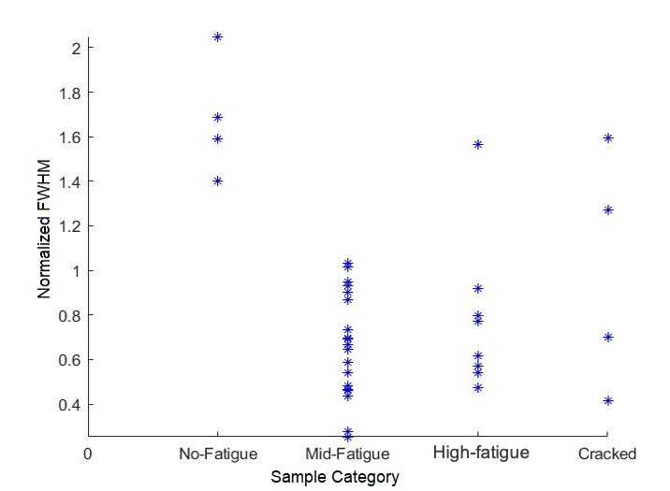

Figure 1.9: Feature 2-- FWHM of MBN signal envelope

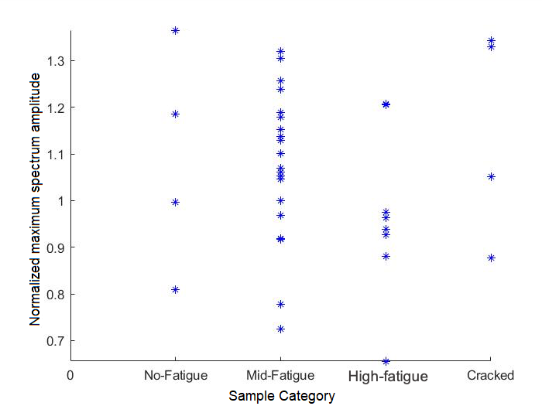

Figure 1.10: Feature 3-- Maximum Spectrum Amplitude

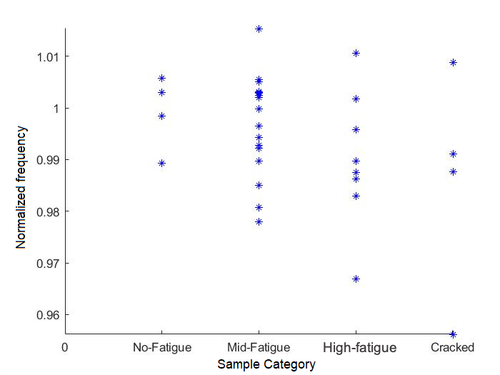

Figure 1.11: Feature 4 -- Frequency for Maximum Spectrum Amplitude

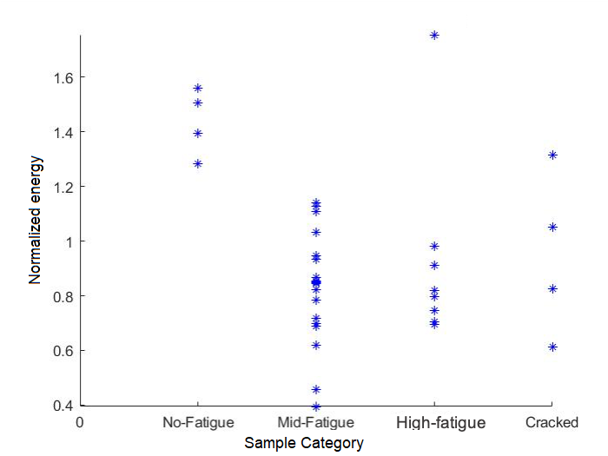

Figure 1.12: Feature 5 – Energy

An alternate way to display the above results is to plot two features together in a two dimensional feature space as presented in Figure 1.13 – 1.16.

Figure 1.13: Feature 1 VS Feature 2

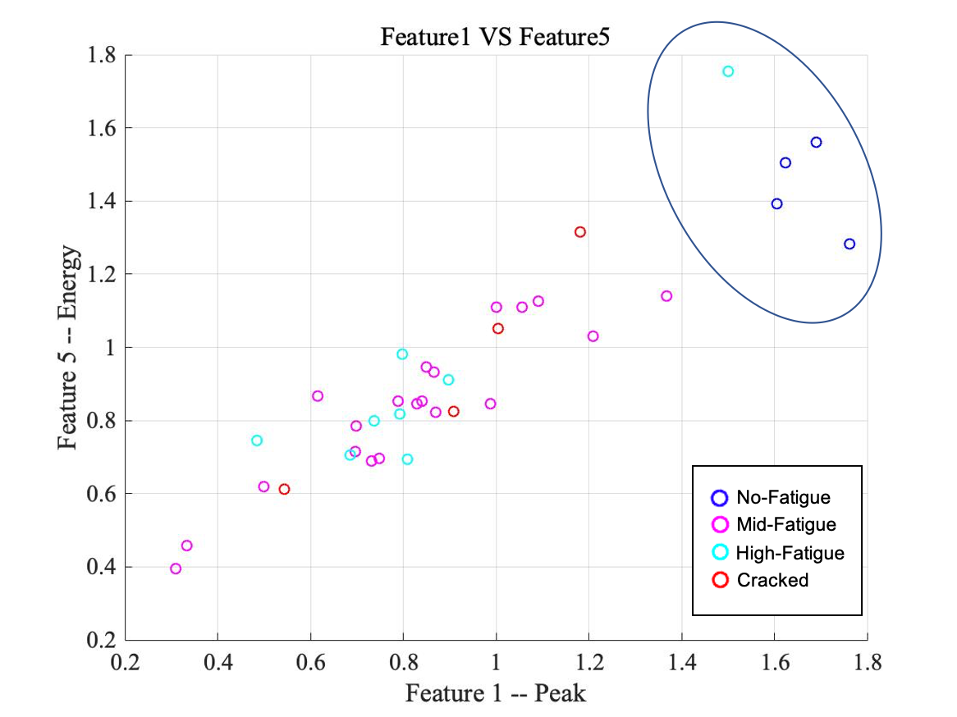

Figure 1.14: Feature 1 VS Feature 5

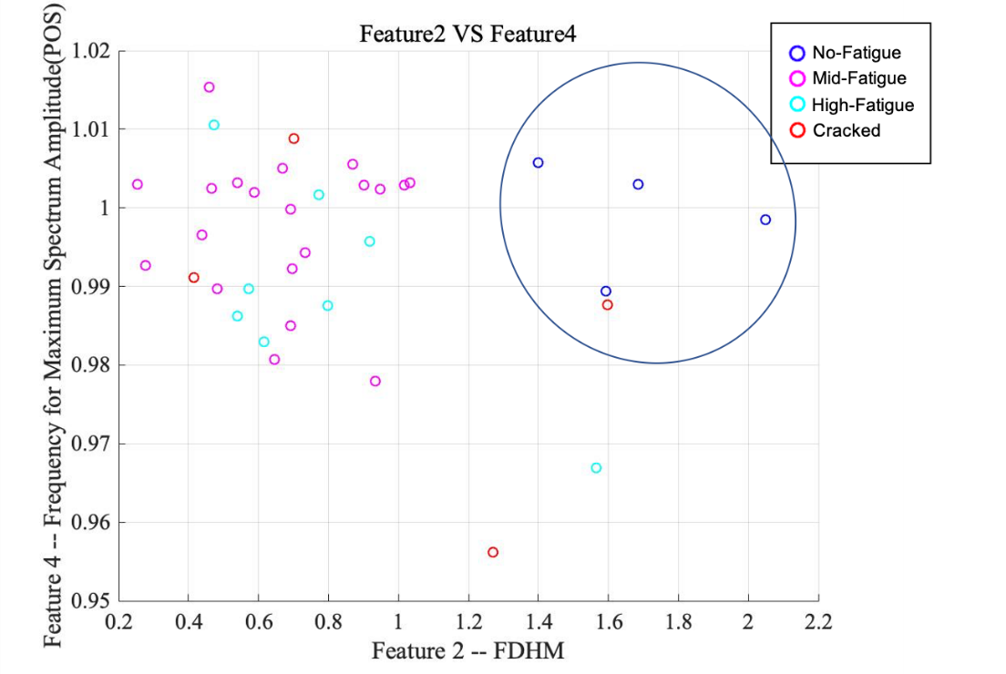

Figure 1.15: Feature 2 VS Feature 4

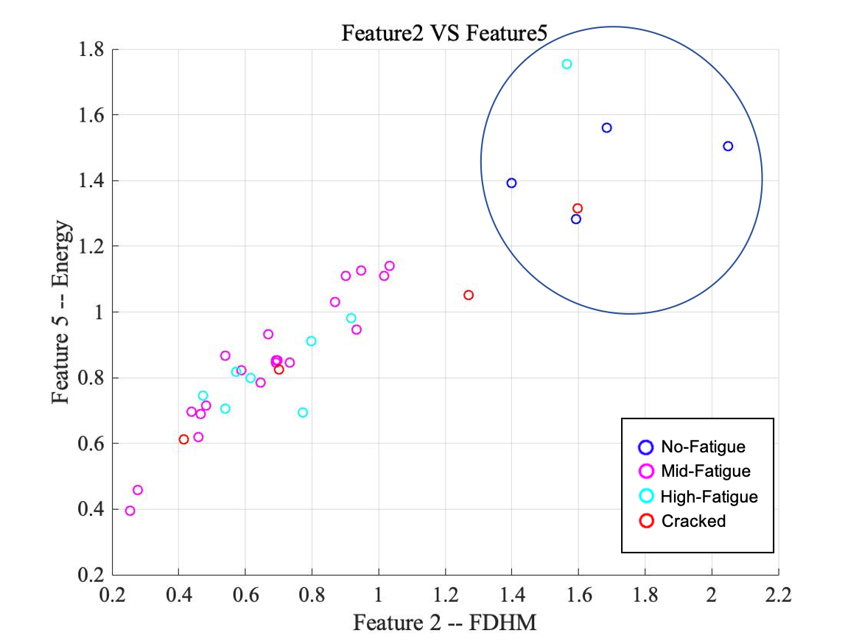

Figure 1.16: Feature 2 VS Feature 5

The No-Fatigue samples for all features lie in a single cluster, which show a considerable separation from other sample categories, i.e. features 1, 2 and 5 show higher values in comparison with other sample categories. The other sample categories do not demonstrate an observable trend and needs further study.

**Method 2: NLE:**

**2.1 Experimental Setup:**

In case of conventional ECT of magnetic steels, the material and operation is largely linear resulting in single frequency component of received signal. However, if the excitation current of ECT system is sufficiently large the material is driven to nonlinear parts of the magnetization characteristics resulting in response signals that contain higher order harmonic frequencies which can be correlated with material fatigue levels.

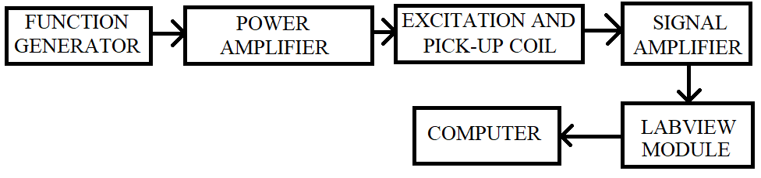

Figure 2.1: Block diagram of NLE Set-Up

Figure 2.1 shows the block diagram of NLE set-up. The function generator is used to generate a low frequency sinusoidal signal which is further amplified using a power amplifier and then given to the excitation coil. The excitation coil is connected in series and pick-up coil is connected in a differential manner. The pick-up coil picks the NLE signature (voltage) generated by the steel sample under test and gives it to the NI DAC card, which is further processed using LabView to generate the NLE data file. The obtained NLE datafile is processed in MATLAB to obtain features relating to the fatigue life of the steel sample under test. The differential probe built to pick up NLE signal is as shown in Figure 2.2. It consists of the reference and measurement probes.

Figure 2.2: Differential NLE probe

The experimental parameters are set in the following way:

* Wave generator output: Sinusoidal signal of 10V (peak to peak) and frequency of 17 Hz
* Power amplifier gain: 10 V/V
* Pick Up coil: 600 turns (32 AWG)
* Excitation coil: 1200 turns (26 AWG)
* Sampling rate: 10,000 Sa/s

**2.2 Data Collection Process:**

Figure 2.3: scanning points

NLE data is collected at four different points, with three of them on the fatigued area (see Figure 2.3) and one reference measurement at a location in the un-fatigued part, marked R in Figure 2.3. The NLE signal from the pick-up coil is given to LabView for processing and the obtained harmonic peaks are processed in MATLAB to make meaningful conclusions.

At the beginning of the NLE implementation phase, in order to simulate the differential response signals, a single electromagnetic excitation-sensor is applied to collect NLE signals at measurement points as well as reference point. The reference signal is then subtracted from all measurements to obtain the differential signal. This was later achieved in hardware using two identical but differentially connected sensors.

**2.3 Data Analysis & Proposed Features:**

Figure 2.4 shows six periods of NLE signals in time domain obtained from samples of two different categories. There is a consistent difference observed in these two signals. Fatigue information is investigated using the frequency spectrum. As previously mentioned, the differential NLE signals are first acquired using a LabView system which averages the response signal over 10 cycles and transforms it to frequency domain as shown in Figure 2.5, indicating the different harmonic peaks of the corresponding signals. Figure 2.6 presents harmonic peak plots of twelve samples, 4 samples in each of three categories, namely unfatigued, mid-fatigue (450 cycles) and high fatigue (900 cycles).

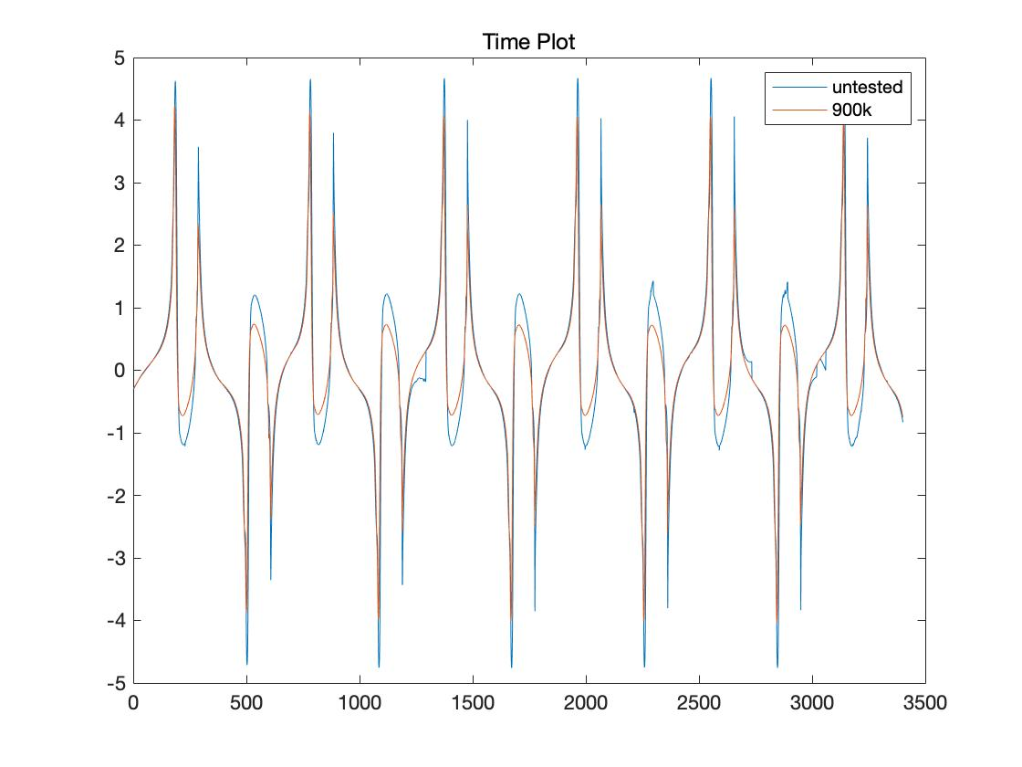

Figure 2.4: Response NLE signals of an untested sample (41C) and a 900k cycles sample (37C)

Figure 2.5: Response frequency spectrum of all samples, excited at 17Hz

Figure 2.6: Harmonic peak plots of all three categories samples (untested, 450k cycles and 900k cycles)

From the frequency spectrum of each differential signal, different harmonic ratio combinations (for example 1st/3rd, 3rd/5th and 5th/7th) and the derivative of harmonic ratios were evaluated and plotted in the feature space.

**2.4 Results:**

Figure 2.7 presents the Harmonic Peak Ratio Plots (1st/3rd, 1st/5th, 1st/7th) of differential NLE signals. The x-axis represents sample number from three categories (untested, 450k cycles and 900k cycles).

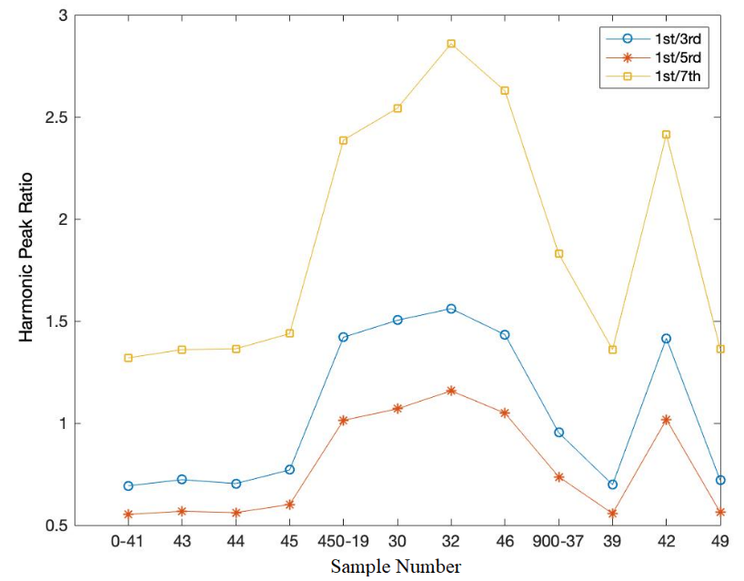

Figure 2.7: Harmonic peak ratio plots of all three categories samples (untested, 450k cycles and 900k cycles)

From the results in Figure 2.7, it is seen that, compared with the untested samples and 900k-cycle samples, the 450k-cycle samples show consistently higher values of harmonic peak ratio. Another way to display the results is to plot the harmonic ratios in the feature space. Figure 2.8 presents the plot of the feature harmonic ratio (1st/3rd) versus the harmonic ratio (1st/5th) and Figure 2.9 shows the plot of harmonics ratio (1st/3rd) versus the harmonics ration (1st/7th).

Figure 2.8: Harmonic peak ratio plots -- 1st/3rd VS 1st/5th

Figure 2.9: Harmonic peak ratio plots -- 1st/3rd VS 1st/7th

Discussion on plots shown in Figures 2.8 and 2.9:

* The harmonic peak ratios of all untested samples lie in distinct ranges, i.e. 0.7-0.78 for 1st/3rd harmonic peak ratio, 0.55-0.6 for 1st/5th harmonic peak ratio and 1.3-1.45 for 1st/7th harmonic peak ratio.
* The harmonic peak ratios of all samples with 450k loading cycles also lie in narrow ranges, i.e. 1.4-1.55 for 1st/3rd harmonic peak ratio, 1-1.15 for 1st/5th harmonic peak ratio and 2.4-2.82 for 1st/7th harmonic peak ratio.
* The harmonic peak ratios of samples with 900k loading cycles are spread out over a relatively wider range.
* Both plots show a separation between untested and fatigued samples. More work needs to be done to determine features that are correlated with different loading cycles.
* The results presented are on a very small set of samples in each category. More extensive testing on a more diverse set of samples need to be done for making definitive conclusions.

**Future Work:**

**3.1 NLE Method:**

One possible approach to enhance the NLE method is to increase the excitation signal amplitude. Data collection using differential measurement for Non-Linear Eddy Current method using an increased current is planned. In order to implement this, we purchased a power amplifier from KEPCO, Inc. The model number and specifications are given below:

* Model No: BOP100-10MG
* Frequency Range: 0 - 2kHz
* Input voltage maximum (peak to peak): 20 V
* Output voltage maximum (peak to peak): 200 V
* Voltage gain: 10
* Power rating: 1000 W

Data processing and analysis of the newly obtained differential NLE data will be the conducted and evaluated.

**3.2 MIP (Magnetic Incremental Permeability) Method:**

Based on the definition of MIP, when a ferromagnetic material is exposed to a steady and static magnetic ﬁeld, the reversible permeability measured with a small alternating magnetic ﬁeld is deﬁned as the MIP and its mathematically is defined as [1]:

(1)

Where, μ0, ΔB, and ΔH are the permeability of air, incremental magnetic ﬂux. density, and incremental magnetic ﬁeld, respectively. The set-up for MIP is given in the next page. In Figure 3.1, a U-shaped electromagnet will be used to excite the steady and static magnetic ﬁeld at low frequency: 0.1Hz to induce a 10kA/m magnetic ﬁeld. For the sensor design: a Hall sensor will be used to measure the Tangential Magnetic ﬁeld strength H; a Transmitter (upper coil) will provide a small alternating magnetic ﬁeld, ΔH and superimposed on the steady large magnetic ﬁeld (deﬁnition of MIP); and a pick up coil used to receive the induced magnetic field which will be fed to a digital lock in amplifier.

Figure 3.1: MIP Set-up diagram in Ref [1]

Based on Figure 3.1, we are designing the sensor (consisting of transmitting coil and pick up coil). The sensor’s 3D holder has already been printed out. The specific experimental parameters will be chosen based on results from the experimental model.

For implementation, we have ordered a waveform generator, from KEYSIGHT TECHNOLOGIES, which has two output channels along with a SYNC functionality. The model number and specifications are given below:

* Number of channels: 2
* SYNC functionality for one of the outputs
* Bandwidth: 20MHz;
* Signal Generator Modulation: AM, BPSK, FM, FSK, PM, PWM, Sum

**Reference (for MIP)**

[1] Magnetic incremental permeability non-destructive evaluation of 12 Cr- MoW-V steel creep test samples with varied ageing levels and thermal treatments